**Smart home automation**

**Requirements:**

Ardunio Uno R3, LED, Resistor, Piezo, Gas sensor, Temperature sensor, Breadboard small.

**Software required:**

Tinkercad software.

**Code:**

float temp;

float vout;

float vout1;

int LED=13;

int gassensor;

int piezo=7;

void setup()

{

pinMode(A0,INPUT);

pinMode(A1,INPUT);

pinMode(LED,OUTPUT);

pinMode(piezo,OUTPUT);

Serial.begin(9600);

}

void loop()

{

vout=analogRead(A1);

vout1=(vout/1023)*5000;

temp=(vout1-500)/10;

gassensor=analogRead(A0);

if(temp>=60)

{

digitalWrite(LED,HIGH);

}

else

{

digitalWrite(LED,LOW);

}

if(gassensor>=100)

{

digitalWrite(piezo,HIGH);

}

else

{

digitalWrite(piezo,LOW);

}

Serial.print("in DegreeC=");

Serial.print(" ");

Serial.print(temp);

Serial.print("\t");

Serial.print("GasSensor=");

Serial.print(" ");

Serial.print(gassensor);

Serial.println();

delay(1000);

}

**Circuit diagram:**

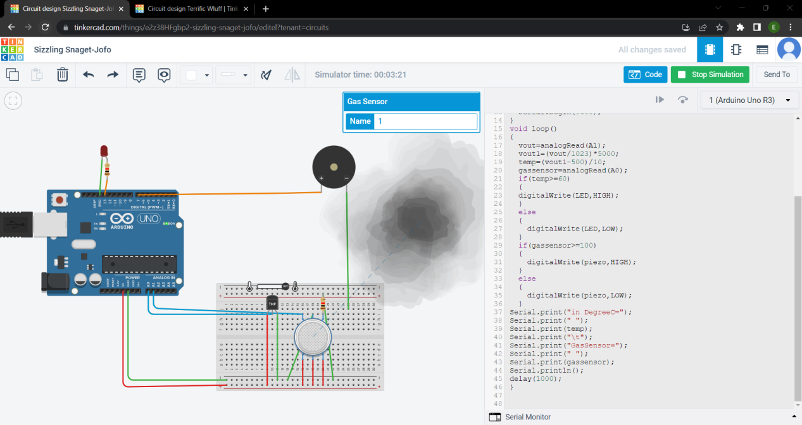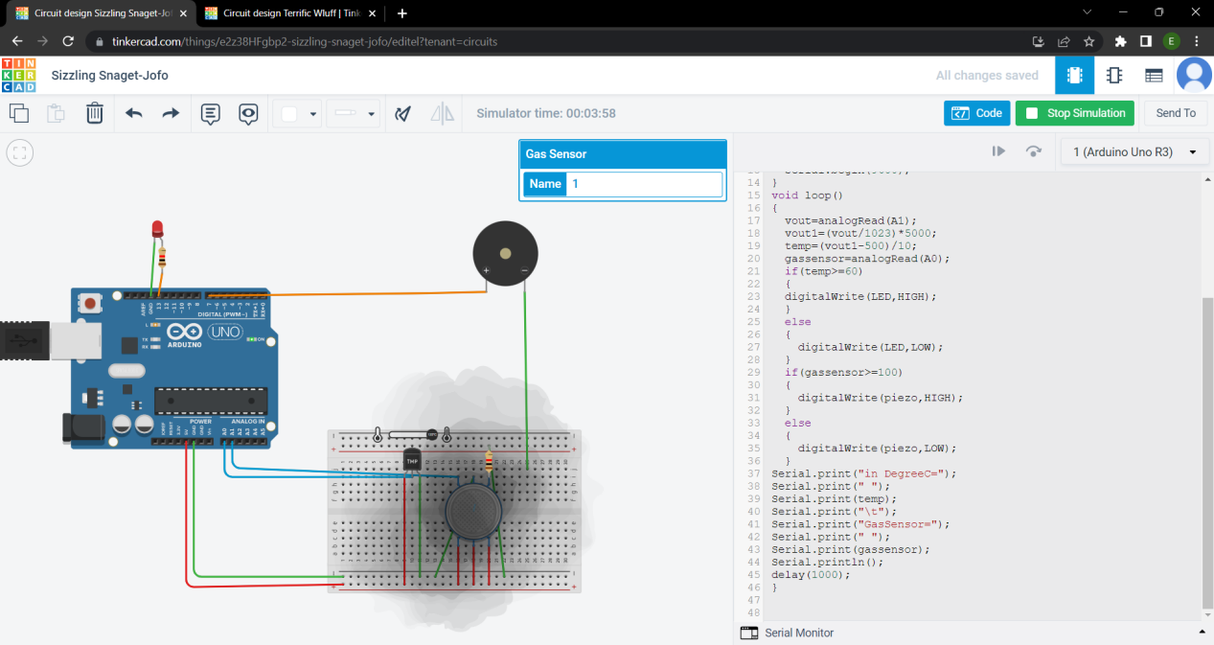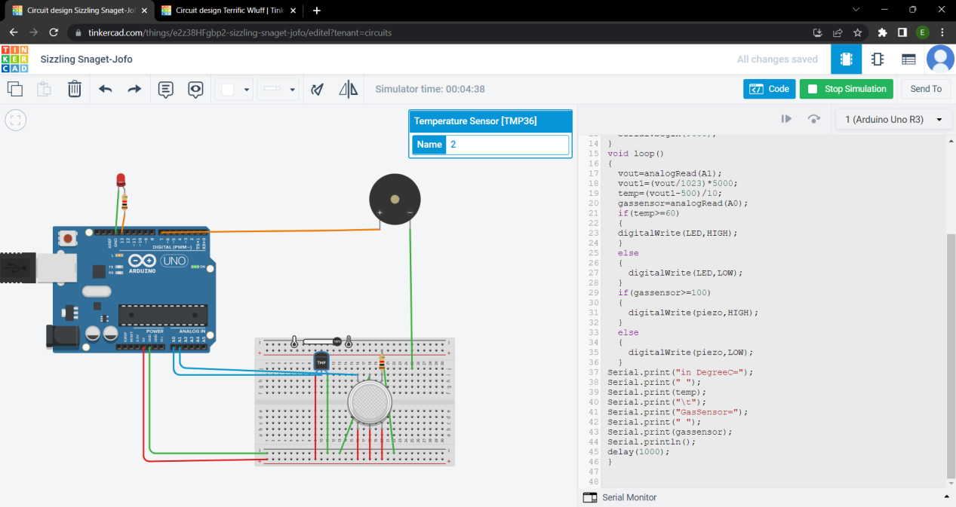

**Schematic diagram:**

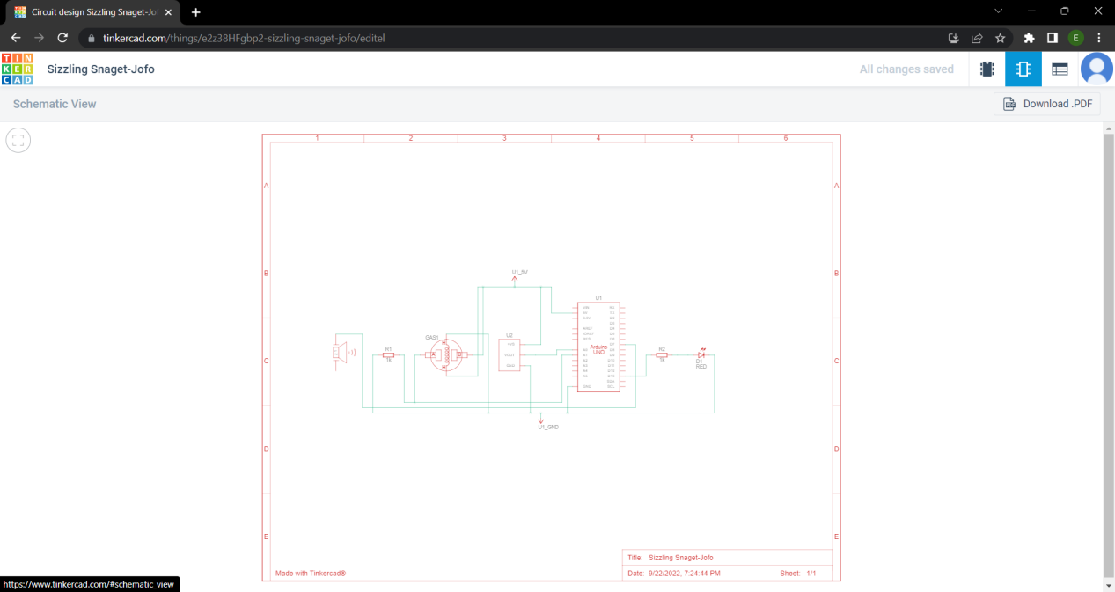

**Demo link:**

<https://www.tinkercad.com/things/e2z38HFgbp2-sizzling-snaget-jofo/editel?sharecode=jHjo8G3a_GklOI4aB_Y-43FNpVFoJvKNYoyTA3JK3Ts>